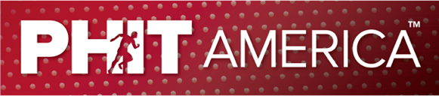
April 2023
HEALTHIER, SMARTER & HAPPIER KIDS

WHO IS PHIT America?

PHIT America is a national 501(c)3 charity improving the physical and mental health of 50 million children in the USA.

PHIT America is attacking a major problem, America’s pandemic, physical inactivity. USA kids are not healthy. UNICEF ranks USA kids last in physical health, 38th out of 38 countries. The British Journal of Sports Medicine has USA kids ranked 47th out of 50 countries in fitness. Nearly 50% of all schools have eliminated physical education. Some schools have no recess.

PHIT America has the solution. We implement better physical activity programs in schools. Our AMPED, PLAY TENNIS, PLAY GOLF, and new PLAY PICKLEBALL programs get kids active…and keep them active. AMPED, PLAY TENNIS and PLAY PICKLEBALL now include Billie Jean King’s Sweet Spot Training System.

PHIT America has great results - We have created 850,000 PHIT KIDS in over 1500 schools who have benefited from PHIT America programs. Our PHIT KIDS are becoming physically and mentally healthier by enjoying the unapparelled 12 Life-Long Benefits of Physical Activity.

PHIT America is led by Jim Baugh, former President of Wilson Sporting Goods and Sports Industry Hall of Fame inductee. More on Jim can be found at Jim.PHITAmerica.org.

KEY LINKS AND INFORMATION
- PHIT America – PHITAmerica.org
- The Problem – IP.PHITAmerica.org
- Our Solutions – Programs.PHITAmerica.org
- Our Results – Info.PHITKids.org
- The Benefits – Benefits.PHITAmerica.org
- Donations – PHITKids.org (will be active on 6/17)
- Most Important Job in America – MostImportantJob.org
- Apply for PHIT Programs – Apply.PHITAmerica.org (will be active on 6/17)
- Tools for you to use – Tools.PHITAmerica.org will be active on 6/17)
- Photos – You can copy and paste from our website

