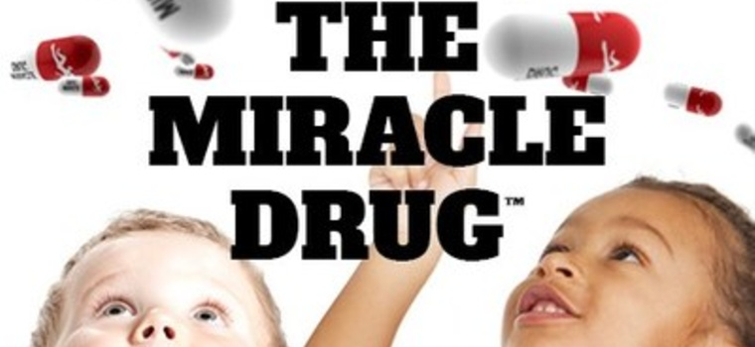

NEW YEAR'S RESOLUTION FOR YOUR KIDS

GET THEM ADDICTED TO THE MIRACLE DRUG™

WASHINGTON, Jan. 4, 2022 /PRNewswire/ -- Do you want to reduce childhood obesity? Decrease Anxiety? Prevent Diabetes? Help them get better grades in school? AND just make kids happier? There is a Miracle Drug every kid should be addicted to. The Miracle Drug is not a pill. The Miracle Drug is a result of increased physical activity that gets kids healthier, happier and will provide a brighter future for our nation's youth.
PHIT America is launching The Miracle Drug (TheMiracleDrug.org) national campaign showing the 12 super benefits of physical activity.
"Our nation's youth are 'healthcare time bombs' and we have the solution to stop it."Jim Baugh, PHIT America founder.
The Miracle Drug is a result of increased physical activity which reduces childhood obesity, decreases anxiety, prevents diabetes, and helps kids lead healthier, happier lives. Research and 12 Super Benefits at PHITAmerica.org. Discover the research behind the 12 Super Benefits of physical activity for kids at TheMiracleDrug.org.
PHIT America Founder Jim Baugh explains, "We have to wake up the world to the all the enormous benefits of physical activity for our kids. There is another big reason we are launching this campaign. People do not understand the tremendous consequences and harm caused by physical INACTIVITY."
"Our kids are in really bad shape," adds Baugh. "Our youth are positioned to be 'healthcare timebombs' and we have to ring the alarm about the 'Inactivity Pandemic!"
- In fact, UNICEF ranks U.S. kids LAST in physical health among 40 countries.
- In a separate study, U.S. kids are ranked 47th out of 50 countries in fitness.
- 50 million out of 58 million U.S. kids are NOT active to CDC physical activity standards.
PHIT America's campaign, The Miracle Drug, will show kids smiling, in wonder, as they watch pills dropping from above. Americans will be guided to learn more at TheMiracleDrug.org where site visitors will discover the 12 super benefits of physical activity along with the research to show how physical activity produces each benefit.
"Obviously, we don't want kids to take pills of any kind," says Baugh. "We do however want to grab America's attention and actually get kids and adults off drugs for the health problems caused by lack of physical activity. Did you know that every year, more than 5 million people die from physical inactivity? We have a serious crisis that needs to get addressed."
PHIT America is planning a major awareness campaign and social media posts to shed light on the real challenges and health concerns that we are facing and remain prevalent in society today.
"Physical Activity is The Miracle Drug. Let's get all kids hooked on Physical Activity for lifelong health, mental wellness and happiness." adds Baugh.
Through its established physical activity programs, PHIT America has introduced over 700,000 kids to physical activity in over 1,200 schools. All data and research sources can be found on IP.PHITAmerica.org. PHIT America is led by Sports Industry Hall of Fame member and former President of Wilson Sporting Goods, Jim Baugh. PHIT America welcomes private and corporate donations to enable our mission to end the Inactivity Pandemic and help us provide free programs, curriculums and equipment to schools. Donate and learn more about PHIT America by visiting PHITAmerica.org. Get involved with the campaign at TheMiracleDrug.org. Find us at Twitter | Facebook | Instagram | LinkedIn
SOURCE PHIT America

