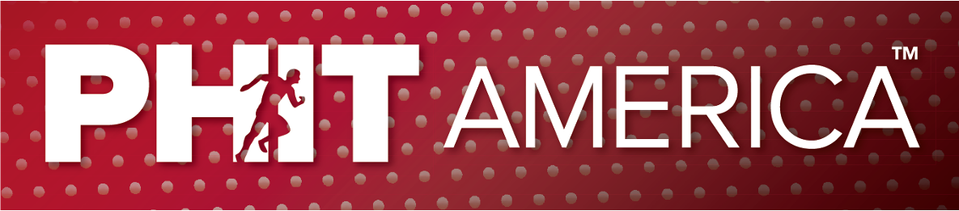
June 2022

HEALTHIER, SMARTER & HAPPIER KIDS

OVERVIEW OF CELEBRITY & CHAMPION SOUNDBITES
WHO IS PHIT AMERICA?
PHIT America is a national 501(c)3 charity improving the physical and mental health of 50 million children in the USA.

PHIT America is attacking a major problem, America’s pandemic, physical inactivity. USA kids are not healthy. UNICEF ranks USA kids last in physical health, 38th out of 38 countries. The British Journal of Sports Medicine has USA kids ranked 47th out of 50 countries in fitness. Nearly 50% of all schools have eliminated physical education. Some schools have no recess.

PHIT America has the solution. We implement better physical activity programs in schools. Our AMPED, PLAY TENNIS and PLAY GOLF programs get kids active…and keep them active. AMPED and PLAY TENNIS now include Billie Jean King’s Sweet Spot Training System.

PHIT America has great results - We have created 740,000 PHIT KIDS in over 1300 schools who have benefited from PHIT America programs. Our PHIT KIDS are becoming physically and mentally healthier by enjoying the unapparelled 12 Life-Long Benefits of Physical Activity.

PHIT America is led by Jim Baugh, former President of Wilson Sporting Goods and Sports Industry Hall of Fame inductee.
KEY LINKS AND INFORMATION
- PHIT America – PHITAmerica.org
- The Problem – IP.PHITAmerica.org
- Our Solutions – Programs.PHITAmerica.org
- Our Results – Info.PHITKids.org
- The Benefits – Benefits.PHITAmerica.org
- Donations – PHITKids.org (will be active on 6/17)
- Most Important Job in America – MostImportantJob.org
- Apply for PHIT Programs – Apply.PHITAmerica.org (will be active on 6/17)
- Tools for you to use – Tools.PHITAmerica.org
- Photos – You can copy and paste from our websited
VIDEO SOUNDBITES CAMPAIGN
We would love to have short 15-20 second video soundbites from friends, celebrities & PHIT Champions. We will potentially use your video soundbite on our website, in social media, etc. Once we receive the video, we will insert your name, title, and key career achievements on the video. You only have to say your name and your soundbite. Your title and accomplishments will be added to the video in script. At the end, we may add the PHIT America or PHIT KIDS logo with a URL. See below examples of short video soundbite.
VIDEO TIPS – USE AN IPHONE or ANDROID IN VIDEO MODE
- Athletic attire is preferred
- Use a vertical layout for your camera.
- Start recording for 1 or 2 seconds before they say anything
- At the end, continue to record 2-3 second after they end.

VIDEO SOUNDBITES - EXAMPLES
(Use any of these or create your own

- Hi, I am xxxx xxxxx. We all want healthy, happy, and smart kids. Getting our kids to move is a good start. I've teamed up with PHIT America to create PHIT Kids! (You can add “in Texas”, any other state, etc.) Here's how you can join the team and create a PHIT Kid.

- Hi, I am xxxx xxxx. Our kids aren’t moving enough. And it’s impacting their mental and physical health. Join me in creating PHIT Kids across The USA (You can add “in Texas”, any other state, etc.). Let's beat the inactivity pandemic and get kids moving!

- Hi, I am xxxx xxx. The more our kids move, they are healthier, happier, and smarter. So, let’s get kids moving by joining PHIT Kids across Texas (or any state). Join me!

- Hi, I am xxxx xxxx. Join me in creating healthy, happy, smart Kids. I'm talking to you! Let's team up and create PHIT Kids throughout Ameirca! (You can add “in Texas”, any other state, etc.).

- Hi, I am xxxxxx xxxxxx. I love what PHIT America is doing. PHIT is improving kids’ physical and mental health with great programs. Join our Team! Go to PHITKids.org to help.

- Hi, I am xxxxxx xxxxxx. I love what PHIT America is doing. PHIT is creating healthier, smarter and happier kids with great programs. Join our Team! Go to PHITKids.org to help.

- Hi, I am xxxxx xxxxx. Did your realize USA Kids are ranked last in physical health? Kids need our help. Help PHIT America like I do. Go to PHITKids.org to learn how.

- Hi, I am xxxxx xxxx. Did you realize almost 50% of schools have no physical education? Kids are way to sedentary and are unhealthy. Help PHIT America solve this issue. Got to PHITKids.org to learn more.

- Hi, I am xxxx xxxxx. Do you want to help kids do better in school? PHIT America is making this happen through great physical activity program. Want to help? Go to PHITKids.org.

- Hi, I am xxxx xxxx. Did you realize active kids do better in school? PHIT America is getting kids active with great physical activity programs. Go to PHITKids.org to help.

- Hi, I am xxx xxxxx. Kids today are more depressed and suffer from mental health issues. PHIT America is solving this issue with great physical activity programs. Help us create more PHIT KIDS. Go to PHITKids.org to learn how.

- Hi, I am xxxx xxxxx. Are you tired of just seeing kids sitting around only moving the thumbs with electronic devices? PHIT America is solving this issue with great school physical activity programs. Go to PHITKids.org to help.

- Hi, I am xxxx xxxx. Have you seen what PHIT America is doing for our kids? We are creating PHIT Kids who are healthier, smarter and happier. Help us create more PHIT Kids.

IF DESIRED, INCLUDE IN ANY SEGMENT (or separately)
- “GET PHIT AMERICA!”,
- “Let’s create a PHIT America.”
- “Help us create more PHIT KIDS”
- “I’ve teamed up with PHIT America”

Interested celebrities with questions should contact Jim Baugh at Jim@PHITAmerica.org.

